Cellular Adaptations, Injury, and Death

Morphologic, Biochemical, and Genetic Bases
Ronald K. Myers, M. Donald McGavin and James F. Zachary
The simple definition that pathology is “the study of disease” understates the wide range of contributions of this discipline to modern medicine. An understanding of pathology is fundamental to developing a mechanistic comprehension of how disease occurs in a chronologic sequence of events and consequently, how it can be diagnosed, treated, and prevented.
To students of medical science, pathology is the course of study that finally connects the study of normal structure and function (histology, anatomy, and physiology) to the study of clinical medicine. Pathology is fundamental to making sense of how the various causes of disease such as infectious microorganisms interact with animals and result in clinically identifiable conditions.
Pathology is also an important professional discipline that directly supports the practice of clinical medicine. Diagnostic pathologists, for example, perform postmortem examinations (necropsies), which provide clinicians with essential information on how to manage disease outbreaks in herds and how to improve management of individual cases. Surgical pathologists examine tissue removed from live animals (biopsy) and provide diagnoses that help clinicians treat animals under their care. Toxicologic pathologists test and evaluate the effects and safety of drugs and chemicals in laboratory animals. Clinical pathologists perform tests on blood and other body fluids (hematology and serum chemistry, for example) and examine cells (cytology) to provide detailed and essential information for clinicians. Experimental pathologists study the tissue, cellular, and molecular mechanisms of human and animal diseases in the fields of biomedicine and biomedical engineering.
Pathology is also an experimental science that makes essential contributions to advance our understanding of disease mechanisms through the use of a diverse variety of scientific techniques. Advanced methods of cell and molecular biology are used to unravel the complexities of how cells and animals respond to injury, so that a deeper understanding of disease processes can help improve treatment and prevention.
In summary, pathology is according to one dictionary definition (Stedman’s Medical Dictionary) “the medical science, and specialty practice, concerned with all aspects of disease, but with special reference to the essential nature, causes, and development of abnormal conditions, as well as the structural and functional changes that result from the disease processes.”

Basic Terminology
If pathology is the study of disease, what is disease? A dictionary definition (Dorland’s Medical Dictionary) states that disease is “any deviation from or interruption of the normal structure or function of any part, organ, or system (or combination thereof) of the body that is manifested by a characteristic set of symptoms and signs and whose etiology, pathology, and prognosis may be known or unknown.” Disease is not just illness or sickness but includes any departure from normal form (lesions) and function, whether it is clinically apparent or not.
Pathologists study lesions, as well as the causes (etiologic agents) of the lesions to understand the pathogenesis of a disease. Pathogenesis is the mechanism of how a disease develops from its initiation to its cellular and molecular manifestations. Understanding pathogenesis is essential to understanding how a disease is initiated and progresses, how these changes relate to clinical signs at different stages of the disease, and how appropriate clinical action can be taken.
The relationship of pathology to clinical medicine and the use of some of the basic terms discussed previously along with some additional terms are illustrated in the following clinical scenario.
In a beef feedlot, several steers and heifers are exhibiting difficult breathing, hunched posture, and depression (clinical signs). Physical examination of some of the infected animals reveals elevated temperatures, pulse rates, and respiration rates. Auscultation of the thorax reveals absence of air movement in the cranial region of the thorax along with some crackles and wheezes in other lung fields. A clinical diagnosis of bronchopneumonia is made. Some of the animals die, and a necropsy (postmortem examination) is done. The cranioventral lobes of the lungs are dark red and firm, with fibrin covering the surface (gross lesions). A gross morphologic diagnosis of severe acute fibrinopurulent cranioventral bronchopneumonia is made. Formalin fixed samples are taken for microscopic examination (histopathology), neutrophilic inflammation of airways and alveoli with fibrin are noted (microscopic lesions), and a histologic morphologic diagnosis of severe acute fibrinopurulent bronchopneumonia is made. Fresh samples of lung are taken for bacterial and viral examination, and Mannheimia haemolytica and a bovine herpes virus (etiologic agents or causes) are identified. An etiologic diagnosis of Mannheimia bronchopneumonia and a disease diagnosis of “shipping fever pneumonia” are made.
The pathogenesis of this disease might be stated in an abbreviated form like the following:
Various viruses, such as infectious rhinotracheitis virus, and environmental agents, such as dust and noxious gases, disrupt the clearance mechanisms of the airway epithelium allowing opportunistic organisms, such as the bacterium Mannheimia haemolytica, to colonize and invade the alveoli. Virulence factors of the bacteria, such as endotoxin and various exotoxins, cause necrosis and inflammation, which result in the filling of alveoli and airways with fibrin and neutrophils.
Although a diagnostic pathologist did the histologic diagnosis of the disease, the details of this pathogenesis were discovered over time by researchers in many fields, including experimental pathologists.

Types of Diagnosis
Note that various levels of diagnosis were made in the previous scenario. Diagnosis is a concise statement or conclusion concerning the nature, cause, or name of a disease. The accuracy of a diagnosis is limited by the evidence (lesions) available for study. A clinical diagnosis is based on the data obtained from the case history, clinical signs, and physical examination. It often suggests only the system involved, or it provides a list of differential diagnoses. The differential diagnosis (often termed rule outs in clinical medicine) is a list of diseases that could account for the evidence or lesions of the case. A clinical pathologic diagnosis is based on changes observed in the chemistry of fluids and the hematology, structure, and function of cells collected from the living patient. A morphologic diagnosis or lesion diagnosis is based on the predominant lesion(s) in the tissue(s) (see Chapter 3 and Fig. 3-23). It may be macroscopic (gross) or microscopic (histologic) and describes the severity, duration, distribution, location (organ or tissue), and nature (degenerative, inflammatory, neoplastic) of the lesion. An etiologic diagnosis is even more definitive and names the specific cause of the disease. A disease diagnosis is equally specific and states the common name of the disease.
One of the goals in making a diagnosis in a case is to enable a clinician to predict how the disease will progress or resolve. Prognosis is a statement of what the expected outcome of a condition is likely to be. If the lesion is expected to resolve (return to normal) with no expected lasting harm, the prognosis is good or excellent. If the outcome is uncertain—the lesion could resolve or become worse as a result of unforeseen factors—the prognosis is guarded. If the animal is not expected to recover from the lesion or disease, the prognosis is grave. Accurate determination of the prognosis demands a thorough understanding of the disease, especially pathogenesis.
As in this book, the study of pathology is often divided into two basic parts: general pathology and pathology of organ systems. General pathology is the study of basic responses of cells and tissues to insults and injuries, irrespective of the organs, systems, or species of animal involved. This area of pathology is one of the most complex and rapidly growing fields in the natural sciences, largely as the result of the availability and power of new research techniques. General pathology is studied first, so students will have a thorough understanding of the general principles of disease processes that they will encounter repeatedly in the study of diseases of body systems. Pathology of organ systems (sometimes called systemic or special pathology) involves the study of how each organ system reacts to injury associated with specific diseases.

Morphologic Changes and How They Are Detected and Evaluated
The study and practice of pathology historically have been based on the macroscopic and microscopic changes that take place in diseased cells, tissues, and organs, that is to say, the morphology of lesions. Consequently, most pathology texts tend to emphasize anatomic pathology. Morphologic techniques remain the cornerstones of pathology, but progress in our deeper understanding of the mechanisms and in the diagnosis of disease rely more and more on techniques derived from cellular and molecular biology.
The basic tools for the study and practice of pathology begin with an open and inquiring mind, skills in observation, and careful and consistent postmortem techniques. The diagnosis of many diseases can be accurately accomplished with no more than gross examination of a body. Confirmation of gross lesions and discovery and interpretation of microscopic changes typically involves observation of tissue placed on glass microscope slides. Tissues are first fixed (i.e., preserved) usually in 10% formalin, embedded in blocks of paraffin wax, microtome sectioned to about 5 µm thickness, and routinely stained with hematoxylin and eosin (H&E). H&E stained sections are the mainstay of histopathology in both postmortem and surgical pathology, and interpretation of lesions in these specimens can often lead to a final diagnosis. A simplistic explanation of the labeling characteristics of the H&E stain as applied to tissue sections is as follows: Hematoxylin stains nucleic acids (nucleus, ribosomes, mitochondria) blue, whereas eosin stains proteins, such as those found intracellularly (e.g., enzymes, actin, and myosin) or those proteins found extracellularly (e.g., collagen and extracellular matrix [ECM]), red or pink.
A variety of ancillary techniques are also used in histopathology. Histochemistry applies a variety of chemical reactions carried out on tissue sections. Glycogen, for example, can be identified in hepatocytes using periodic acid–Schiff (PAS) reaction. Suspected mast cell tumors are routinely stained to demonstrate the metachromatic mast cell granules using toluidine blue or Giemsa stains.
Increasing use in diagnostic laboratories is being made of immunohistochemistry, in which specific antigens are identified in tissue by antibodies linked to a chromogen. Detection of specific intermediate fibers by immunohistochemistry, in tumors, for example, can separate malignant striated muscle tumors from other sarcomas. Specific infectious agents, such as the coronavirus causing feline infectious peritonitis, can also be identified using immunohistochemistry.
A variety of techniques for identification of molecules or genetic sequences are now in use, with more expected. In situ hybridization, in which labeled nucleic acid probes can identify complementary strands of host or microbe deoxyribonucleic acid (DNA) or ribonucleic acid (RNA) in intact cells and tissues, is particularly useful in the diagnosis and study of viral disease. These techniques are not as sensitive as polymerase chain reaction (PCR), in which small amounts of target DNA in biologic material are amplified and identified. Small amounts of target DNA of microbes (for example) can be identified in tissues, and RNA sequences can be identified after conversion to DNA and subsequent amplification.
The typical light microscope can magnify to about 1000× and is adequate for routine histopathology. Specialized microscopes, such as dark field, phase contrast, and fluorescence microscopes, are also used, often for identification of microbes. In both diagnostic and experimental settings, electron microscopy is used to visualize the subcellular structure of cells and microbes. Transmission electron microscopy of ultrathin sections allows resolution of ultrafine structures of less than a nanometer. Scanning electron microscopy allows the ultrafine observation of surfaces. Specialized analytical electron microscopes are also in use. Finally, laser capture microdissection allows pathologists to isolate and capture groups of similar cells from tumors or a diseased tissue. Using DNA microarrays and other genomic techniques, the genes expressed by these cells can be identified and characterized, thus providing a “genetic fingerprint” of the disease process that clinically can be used to develop therapeutic strategies and assess the outcome. Proteomics, which are molecular techniques used to reveal the protein profiles from genes in tissues and fluids, are also being increasingly used.

The Normal Cell
Components Of Normal Cells And Their Vulnerabilities
The early pathologists Morgagni and Bichat emphasized the importance of organs and tissues as the seat of disease. Virchow later focused on individual cells as the primary cause of abnormal function and structure associated with diseases. Before we can interpret lesions of sick cells, it is essential that we understand normal cell structure and function. The cell can be visualized simplistically as a membrane-enclosed compartment, subdivided into numerous smaller compartments (organelles) by membranes (Fig. 1-1). This vast interconnecting system of membrane-bound spaces is termed the cytocavitary network. The function of these organelles is largely determined by the type and quantity of specific enzymes associated with each membrane and in the cytoplasmic matrix.
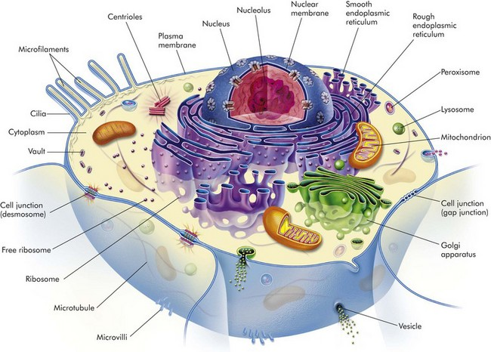
FIG. 1-1 Cell structure and the organization of organelles, cytoskeleton, and membrane enhancements. (From McCance K, Huether S: Pathophysiology: the biologic basis for disease in adults and children, ed 5, St Louis, 2006, Mosby.)
It is essential to have a clear understanding of the structure and function of the components of normal cells and how they are interrelated in a normally functioning cell. Cell membranes and organelles serve as targets for injury by microbes, harmful environmental agents, and a variety of genetic, metabolic, and toxicologic diseases discussed in greater detail in the Pathology of Organ Systems chapters of this book.

Cell Membranes
Cell membranes are a fluid phospholipid bilayer penetrated by numerous specific proteins (Fig. 1-2). The two main biologic functions of these membranes are (l) to serve as selective barriers and (2) to form a structural base for the enzymes and receptors that determine cell function. Cell membranes form the boundaries of many organelles and separate them from the cytosol.
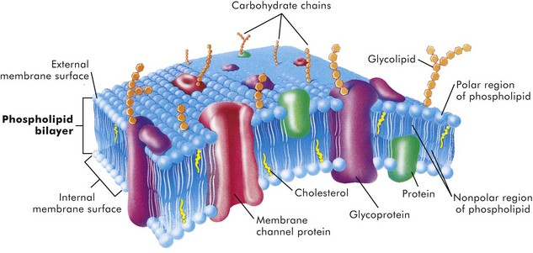
FIG. 1-2 Fluid mosaic model of cell membrane structure.The lipid bilayer provides the basic structure and serves as a relatively impermeable barrier to most water-soluble molecules. (From McCance K, Huether S: Pathophysiology: the biologic basis for disease in adults and children, ed 4, St Louis, 2002, Mosby.)
The plasma membrane is the cell’s first contact with injurious agents. Microvilli and cilia are specialized areas of the plasma membrane and are often specifically altered in disease (see Fig. 1-1). Plasma membranes separate the interior of the cell from external surfaces, neighboring cells, or surrounding matrix. Surface proteins, such as fibronectin, play a role in cell-to-cell and cell-to-ECM interactions. Transmembrane proteins embedded in the phospholipid bilayer serve in a variety of structural, transport, and enzymatic functions essential to cell viability (Fig. 1-3). It is these transmembrane proteins that are often used by infectious microbes to enter or use cell systems during their life cycles, thus initiating a process that often results in injury to the host cell.
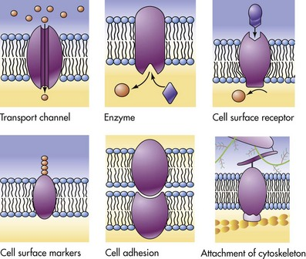
FIG. 1-3 Functions of transmembrane proteins.A variety of functions are performed by different types of cell membranes as shown. (From McCance K, Huether S: Pathophysiology: the biologic basis for disease in adults and children, ed 5, St Louis, 2006, Mosby.)

Cytosol
The cytosol is the watery gel in which the cell’s organelles and inclusions are dispersed. Many chemical reactions occur in the cytosol mediated by “free” enzymes or macromolecular complexes such as proteasomes. The cytosol is a highly organized microtrabecular network.

Mitochondria
Mitochondria (singular = mitochondrion) are the “powerhouses” of highly specialized eukaryotic cells. They are the site of fatty acid oxidation, the citric acid cycle, and oxidative phosphorylation. Transfer of electrons from reduced cytochrome oxidase to molecular oxygen is the final and critical step culminating in these catabolic pathways. Important structural components of a mitochondrion are the outer membrane, outer compartment, inner membrane, inner compartment (matrix), cristae, and mitochondrial DNA. Damage to mitochondria results in diminished adenosine triphosphate (ATP) production and if damage is unchecked, cell death (see Fig. 1-6).

Nucleus
The nucleus is that portion of the cell responsible for storage and transmission of genetic information (see Fig. 1-1). Chains of DNA, complexed to protein, are chromatin. Areas of uncoiled chromatin (euchromatin) are active in the generation of messenger RNA (mRNA) for protein synthesis. Highly coiled chromatin (heterochromatin) is inactive in transcription. The outer nuclear membrane is continuous with that of the rough endoplasmic reticulum (RER).

Nucleolus
The nucleolus is a basic organelle of the nucleus and is composed of RNA, nucleolus-associated chromatin, and protein (see Fig. 1-1). It functions in the synthesis of ribosomal RNA (rRNA), essential in protein synthesis. The nucleolus can be basophilic or eosinophilic, and its prominence is a subjective measure of the cell’s synthetic activity.

Rough Endoplasmic Reticulum
The RER is a network of intracellular membranes studded with ribosomes (Fig. 1-4). RER is prominent in cells producing large amounts of extracellular protein (e.g., reactive fibroblasts, hepatocytes, plasma cells, and pancreatic acinar cells). The RER is responsible for the basophilia of the cytoplasm because of the numerous ribosomes, which contain acid (i.e., RNA).
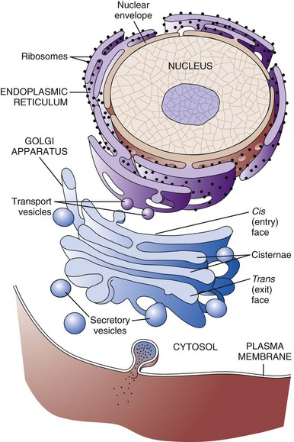
FIG. 1-4 Membrane systems.The rough endoplasmic reticulum and Golgi apparatus are important organelles in cellular biosynthesis of proteins and glycoproteins inserted into cell membranes and used in and secreted from cells. Transcription, translation, assembly, modification, and packaging of these molecules occur in an orderly sequence from the nucleus to the cell membrane as shown. Alterations in one or more of these steps can result in cell injury and serve as the underlying pathogenesis of a disease process. (From Copstead L, Banasik J: Pathophysiology, ed 4, St Louis, 2010, Mosby.)

Smooth Endoplasmic Reticulum
Smooth endoplasmic reticulum (SER) is a tubular or vesicular form of cell membrane that lacks ribosomes (see Fig. 1-1). SER is the locus of enzymes that metabolize steroids, drugs, lipids, and glycogen. It gives the cytoplasm a pale, finely vacuolated appearance as viewed in the light microscope.

Golgi Complex
The Golgi complex consists of several lamellar stacks or flattened sacs of membranes, vesicles, and vacuoles (see Fig. 1-4). It functions in the synthesis of complex proteins by the addition of carbohydrate molecules and in the production of secretory vesicles and lysosomes.

Lysosomes
Lysosomes are small membrane-bound vesicles laden with hydrolytic enzymes essential for intracellular digestion (see Fig. 1-1). They are discussed more completely as components of phagocytic cells. Peroxisomes are similar to lysosomes but also play a role in energy metabolism.

Microfilaments, Intermediate Filaments, and Microtubules
These structures are composed of protein subunits and function in the cytoskeleton and in cell movement (Fig. 1-5). They have a prominent role in the mitotic spindle, cilia, microvilli, neurons, myocytes, and phagocytic cells. Many cell types besides muscles, for example, contain actin microfilaments.
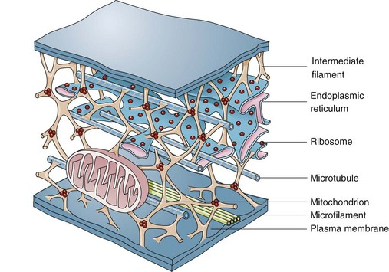
FIG. 1-5 Cytoskeleton.The complexity of and interrelations between intermediate filaments, microtubules, endoplasmic reticulum, and other cytoplasmic organelles that can be involved in the pathogenesis of diseases are shown. (From McCance KL, Huether SE: Pathophysiology: the biologic basis for disease in adults and children, ed 5, St Louis, 2006, Mosby.)
Intermediate filaments are about 10 nm in diameter and are important in cell shape and movement. Different cell types have different intermediate filaments; for example, cytokeratins are found in epithelial cells, desmin in muscle cells, and vimentin in cells of mesenchymal origin such as fibroblasts. Intermediate filaments can be useful markers for classifying undifferentiated neoplasms.

Cellular Inclusions
Inclusions include glycogen granules, proteinaceous vacuoles, lipid debris, hemosiderin, viral particles, and calcium granules (discussed in greater detail later in this chapter). Some of these are normal, whereas others are the result of cell injury and are discussed later in this chapter in the section dealing with intracellular and extracellular accumulations.

Extracellular Matrix
Although not part of the cell itself, the ECM and its integrity influences cell health and function (see Chapter 3 and Web Figs. 3-23 and 3-24). ECM includes basement membranes and interstitial matrices composed of various collagens, proteoglycans, and adhesive glycoproteins among a variety of other molecules that interact with cells by means of various integrin molecules. Basement membrane integrity, for example, is essential for the proper structure and functioning of epithelial cells. Other components of the ECM influence how cells grow and differentiate.

Causes of Cell Injury
Causes of cell injury are numerous and can be classified in a variety of ways. Some causes, such as physical trauma, viruses, and toxins, are clearly extrinsic, whereas others, such as spontaneous genetic mutations, are clearly intrinsic. Others, such as workload imbalance, nutritional abnormalities, and immunologic dysfunctions, can have components of both extrinsic and intrinsic mechanisms. General mechanisms of injury include ATP depletion (often caused by hypoxia), membrane damage (a result of a myriad of causes, including oxygen-derived free radicals), disturbances of cellular metabolism, and genetic damage (Fig. 1-6).
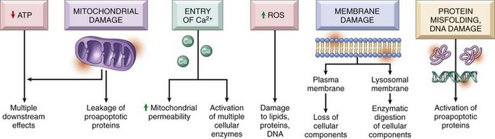
FIG. 1-6 Cellular and biochemical sites of damage in cell injury.ATP, Adenosine triphosphate; ROS, reactive oxygen species. (From Kumar V, Abbas A, Fausto N, et al: Robbins & Cotran pathologic basis of disease, ed 8, Philadelphia, 2009, Saunders.)
Understanding disease starts with understanding the cell. Until the nineteenth century, the dominant theory of disease in western societies was humoral pathology, wherein disease was attributed to a maldistribution of body fluids or “humors.” In the mid-1800s, Rudolph Virchow, a German pathologist now considered to be the founder of modern pathology, redefined pathology and medical science with his idea of the body as an organization of cells, each suited for specific functions. He taught that disease resulted from injury to, or dysfunction of, specific populations of cells. The recent rapid advancement in medical science is owed to a great extent to Virchow’s original emphasis on cellular pathology and more recently on molecular pathology.
Cells can be injured through a large number of causes (etiologic agents). Fortunately, the types of responses of the cell to injury are not as large. The responses to injury depend on many factors, including the type of agent, the extent of injury, the duration of injury, and the cell type affected. Renal tubular cells deprived of adequate blood supply, for example, may exhibit only cell swelling, if oxygen is soon restored. Prolonged lack of adequate blood supply (ischemia) can lead to cell death. Diminished but sublethal reduction in blood supply may result in cells adapting by decreasing their metabolic rates, which could lead to recovery or if adaptation is inadequate, eventually death.
Cells respond to stimuli and stressors in a variety of ways to maintain homeostasis. Cell injury takes place when a cell can no longer maintain a steady state. Some types of cell injury, such as cell swelling, can be reversible if the extent and duration of injury are not excessive. But if the injury exceeds certain limits, cell death and irreversible change occur. Not all cell injury results in cell death. Cell injury may be sublethal and result in a variety of types of cell degenerations or accumulations and/or adaptations by the cell to the injury. In essence, cells or tissues respond to injury (or stress) in three important ways: (l) adaptation, (2) degeneration or intracellular or extracellular accumulations, and (3) death (Fig. 1-7).
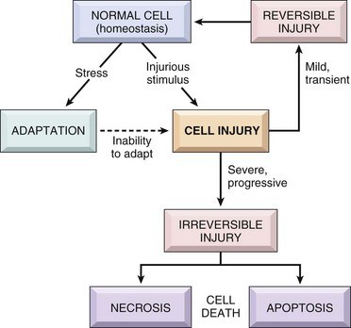
FIG. 1-7 Stages in the cellular response to stress and injurious stimuli. (From Kumar V, Abbas A, Fausto N, et al: Robbins & Cotran pathologic basis of disease, ed 8, Philadelphia, 2009, Saunders.)
Pathologically, reversible cell injury is injury from which the cell can adapt or recover and thus return to normal or nearly normal function. Irreversible cell injury results in a dead cell. This distinction seems clear-cut, but the point at which a cell transitions from reversible cell injury to irreversible cell injury (i.e., “the point of no return”) has been a major research challenge for the past few decades and remains so today (Fig. 1-8). The lesions of reversible and irreversible cell injury are discussed in greater detail in subsequent sections; however, in summary, the cytomorphologic changes characteristic of irreversible cell injury include the following:
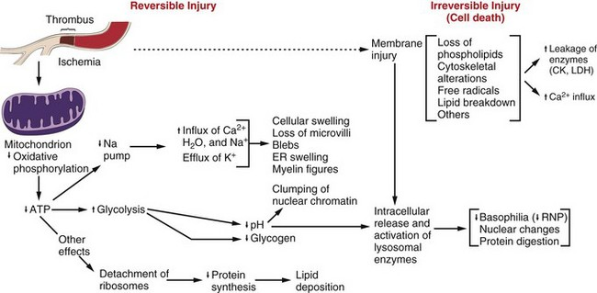
FIG. 1-8 Postulated sequence of events in reversible and irreversible ischemic cell injury.Note that although reduced oxidative phosphorylation and adenosine triphosphate (ATP) levels have a central role, ischemia can cause direct membrane damage. ER, Endoplasmic reticulum; CK, creatine kinase; LDH, lactate dehydrogenase; RNP, ribonucleoprotein. (From Kumar V, Abbas A, Fausto N: Robbins & Cotran pathologic basis of disease, ed 7, Philadelphia, 2005, Saunders.)
• Plasma membrane damage
• Calcium entry into the cell
• Mitochondrial swelling and vacuolization
• Amorphous densities (likely calcium) in the mitochondria
• Lysosomal swelling
The causes of reversible and irreversible cell injury resulting in cell death, cell adaptation and degeneration, and finally cellular accumulations are now discussed.

Oxygen Deficiency
Hypoxia is one of the most common and important causes of cell injury and death (see Fig. 1-8). Hypoxia is a partial reduction in the O₂ concentration supplied to cells or tissue; a complete reduction is referred to as anoxia. Oxygen is critically important for oxidative phosphorylation, especially in highly specialized cells such as neurons, hepatocytes, cardiac myocytes, and renal tubule cells. Hypoxia can result from inadequate oxygenation of blood as a result of heart failure or respiratory failure, loss or reduction of blood supply (ischemia), reduced transport of O₂ in blood (e.g., anemia or carbon monoxide toxicity), and blockage of cell respiratory enzymes (cyanide toxicosis).

Physical Agents
Trauma, extremes of heat and cold, radiation, and electrical energy may seriously injure cells. Trauma may cause direct rupture and death of large numbers of cells, or it may damage the blood supply to cells. Extreme cold impairs the blood flow, and intracellular ice crystals rupture cell membranes. Extreme heat denatures essential cell enzymes and other proteins. Excessive heat can increase the rate of metabolic reactions so that substrates, water, and pH changes reach lethal levels. Electricity generates great heat as it passes through tissue. It also alters conduction of nerves and muscle. Ionizing radiation causes ionization of cellular water with production of highly reactive “free radicals” that injure cell components. Many forms of radiation may damage genetic material, resulting in reproductive death of cells by apoptosis, genetic defects from mutations, and neoplasia.

Infectious Agents
Viruses are obligate intracellular parasites that redirect host cell enzyme systems toward synthesis of viral proteins and genetic materials to the detriment of host cells. Cell changes induced by viral agents vary from little effect to cell death or neoplastic transformation.
Injury caused by bacterial infection varies and can result from the action of potent toxins on specific host cells (clostridial infections, enterotoxigenic Escherichia coli infection) or from an overwhelming or ineffective inflammatory response to uncontrolled bacterial replication in tissue. Some bacteria, such as Lawsonia intracellularis, can result in excessive intestinal epithelial cell replication.
Mycotic agents resist destruction by the body that can lead to progressive, chronic inflammatory disease with loss of normal host tissues. Protozoal agents replicate in specific host cells, often resulting in destruction of infected cells. Metazoan parasites cause inflammation, distort tissue, and use host nutrients.

Nutritional Deficiencies And Imbalances
Dietary protein-calorie deficiencies are seen sporadically in animals and humans (known as kwashiorkor). These deficiencies require metabolic adaptation by large populations of cells. Lipolysis, catabolism of muscle protein, and glycogenolysis enable short-term survival. Calorie excess, as seen in many pets and people of affluent societies, is implicated in cardiovascular disease and several other diseases. Vitamin and mineral imbalances are common due to errors in formulating rations and hypersupplementation by well-meaning animal owners.

Genetic Derangement
A normal genetic apparatus is essential for cell homeostasis. Mutations, whatever their origin, may cause no disease, may deprive a cell of a protein (enzyme) critical for normal function, may result in neoplasia, or may be incompatible with cell survival. A few examples of genetic diseases are defects of clotting factors (hemophilia), lysosomal storage disease (mannosidosis), combined immunodeficiency of Arabian foals, and defects of collagen synthesis (dermatosparaxis). Besides causing overt disease, some genotypes cause the host to be more prone to certain types of extrinsic or intrinsic disease, a condition often termed genetic predisposition.

Workload Imbalance
Cells that are overworked may adapt to the demand or eventually become exhausted and die. Conversely, cells that are no longer stimulated to work may shrink in size and waste away. An example is the way endocrine tissues react to the presence or absence of specific trophic hormones. Muscle fibers, deprived of work or their nerve supply, will atrophy and ultimately disappear, leaving a fibrous stroma.

Chemicals, Drugs, And Toxins
Chemicals, drugs, and toxins influence cells by a multitude of mechanisms. Drugs produce their therapeutic effects by modifying the function (and morphology) of specific populations of cells. Most drugs cause these cells to adapt within a tolerable range of homeostasis. Chemicals, including drugs and toxins, can block or stimulate cell membrane receptors, alter specific enzyme systems, produce toxic free radicals, alter cell permeability, damage chromosomes, modify metabolic pathways, and damage structural components of cells.

Immunologic Dysfunction
The immune system may fail to respond to infectious agents and other antigens as a result of congenital or acquired defects of lymphoid tissue or their products (see Chapter 5). Examples of congenital defects are thymic aplasia of nude mice and combined immunodeficiency of Arabian foals. Affected animals may die at an early age from infection by opportunistic microorganisms. Acquired immunodeficiency disease may be transient and results from damage to lymphoid tissue by viral infection, chemicals, and drugs.
The immune response directed toward foreign antigens (pathogenic organisms) is usually beneficial to the host, but sometimes the response is misdirected against antigens of host cells. This large group of diseases is referred to as autoimmune disease. An inappropriate or exaggerated response to certain antigens results in immunologic disease referred to as hypersensitivity (allergy). Some examples are anaphylaxis, feline asthma, and flea allergy dermatitis. The activity of the immune system is greatly amplified by its effect on serum complement and inflammation. These reactions often lead to serious injury to the kidney, skin, and joints.

Aging
The diminished capacity of aged cells and tissue to carry out their normal functions can hardly be disputed. One can argue that aging is simply the culmination of life’s injuries inflicted by chemicals, infectious agents, work imbalances, or poor nutrition. We use the aging category for those lesions commonly found in aged animals; lesions for which we have no other defensible mechanistic explanation. Some of the lesions commonly found in older animals include nodular hyperplasia of parenchymal cells in the liver, pancreas, adrenal, spleen, and thyroid. There appear to be defects in growth control of these cell populations, but the cause is unclear. Aged cells may suffer a lifetime of damage to their DNA, or there may be accumulation of cellular debris that interferes with normal cell functions. One could argue that many cancers are caused by old age, rather than by exposure to specific chemicals, foods, viruses, or other insults.

Reversible Cell Injury
Acute Cell Swelling
Cell swelling, also called hydropic degeneration and by other names in different organ systems (e.g., cytotoxic edema in the central nervous system and ballooning degeneration in the epidermis), is the most common and fundamental expression of cell injury (Fig. 1-9). It is manifested as increased cell size and volume resulting from an overload of water caused by a failure of the cell to maintain normal homeostasis and regulate the ingress and excretion of water. It is accompanied by modification and degeneration of organelles. Mechanisms responsible for acute cell swelling usually involve damage to cellular membranes, failure of cellular energy production, or injury to enzymes regulating ion channels of membranes. Cell swelling occurs in response to loss of the cell’s homeostasis secondary to mechanical, hypoxic, toxic, free radical, viral, bacterial, and immune-mediated injuries.
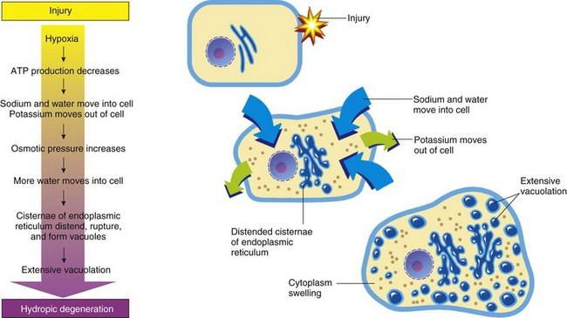
FIG. 1-9 The process of acute cell swelling (hydropic degeneration).ATP, Adenosine triphosphate. (From Huether S, McCance K: Understanding pathophysiology, ed 3, St Louis, 2004, Mosby.)
The functional and morphologic changes begin with increased uptake of water and then to diffuse disintegration of organelles and cytoplasmic proteins. Cell swelling must be distinguished from cell enlargement (hypertrophy) that is caused by an increase of normal organelles. Organs composed of swollen cells are themselves swollen. Affected organs are larger and heavier than normal and pale in color. The parenchyma of swollen organs, such as kidney and liver, may bulge a little from beneath their capsule when incised. Because of the increase of intracellular water, the specific gravity of affected tissues is slightly less than those of normal tissues.

Normal Cell Volume Control and Mechanisms of Acute Cell Swelling
In the normal cell, energy derived from ATP drives the Na⁺-K⁺ ion pumps within cell membranes to continuously drive Na⁺ out of the cell in exchange for K⁺ moving into the cell. For each molecule of ATP used, the pump moves three Na⁺ out of the cell and two K⁺ into the cell. By this means, the ion pumps maintain the transmembrane ionic gradients required for normal nerve and muscle function. Because water moves passively across cell membranes in response to the osmotic pressure gradient generated by Na⁺ and proteins, the Na⁺-K⁺ pump is the key to regulation of intracellular water. The best-studied laboratory models of cell swelling are (1) hypoxia-induced failure of ATP synthesis and (2) carbon tetrachloride (CCl₄)–induced membrane damage.

Hypoxic Injury Resulting in Acute Cell Swelling
Hypoxia is probably the most important fundamental cause of acute cell swelling. Hypoxia-induced cell injury results from any defect in the transport of O₂, from inspired air to its role as the final acceptor of electrons from cytochrome oxidase in oxidative phosphorylation. Ischemia is reduced blood flow to a region of the body, usually because of obstruction of the blood supply. Blockage of coronary arteries by atherosclerotic plaque leads to ischemia and hypoxic injury to heart muscle, a common cause of “heart attacks” in humans. Therefore cellular hypoxia occurs with suffocation, anemia, pneumonia, shock or other damage to the circulation, and interference with mitochondrial enzymes.
In acute hypoxic injury, cell O₂ is depleted in moments, aerobic oxidative phosphorylation stops, and ATP levels fall. The drop in cellular ATP stimulates phosphofructokinase, the initial regulator step of anaerobic glycolysis. The metabolic switch to anaerobic metabolism of glucose rapidly depletes the cell’s glycogen stores and leads to the accumulation of intracellular lactate and inorganic phosphates. Although the anaerobic generation of ATP is inefficient, it provides for some short-term survival. Some highly specialized cell types, such as neurons, cannot generate ATP anaerobically and thus are especially prone to hypoxic injury. Ultimately, this deficiency of ATP leads to a failure of Na⁺-K⁺ pumps and loss of cell volume control.
The cardiac glycosides of plant origin, digitalis and ouabain, specifically inhibit the action of the Na⁺-K⁺ pump. This inhibition modifies the contractility of cardiac myocytes, but it may also cause them to swell.

Cell Membrane Injury in Acute Cell Swelling
Damage to the cell membranes, both plasma membranes and organelle membranes, destroys the selective permeability barrier that retains proteins and electrolytes within the cytosol and that restricts the entry of Na⁺, Ca²⁺, and water from the extracellular space. Failure of the barrier results from chemical modification of phospholipids by free radicals, covalent binding of toxic chemicals to macromolecules, interference with ion channels, and insertion of transmembrane protein complexes (e.g., complement activation).
The hepatotoxicities of CCl₄ and chloroform (CHCl₃) provide classic examples of cell membrane injury (Fig. 1-10). Toxic effects of CCl₄ occur when the chemical is converted to the trichloromethyl radical, CCl₃•, by the mixed-function oxidase system of the SER in hepatocytes. The toxic metabolite, CCl₃•, next causes progressive lipid peroxidation of unsaturated fatty acids of cellular membranes, progressing from the SER to mitochondria and other cell membranes. Chloroform is toxic to hepatocytes when it is metabolized to the electrophilic metabolite, phosgene (COCl₂•). The hepatic lesions associated with these two toxins are indistinguishable, and both may result in fatty liver.
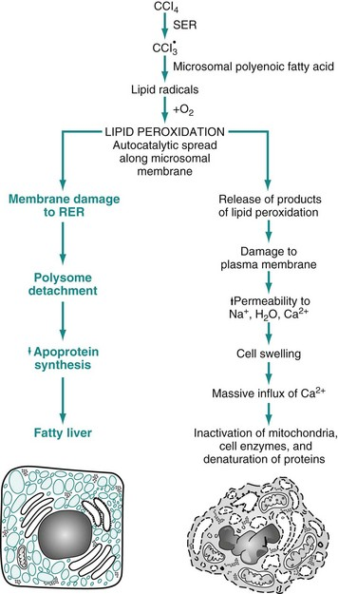
FIG. 1-10 Sequence of events leading to fatty change and cell necrosis in carbon tetrachloride (CCl₄) toxicity.RER, Rough endoplasmic reticulum; SER, smooth endoplasmic reticulum. (From Kumar V, Abbas A, Fausto N: Robbins & Cotran pathologic basis of disease, ed 7, Philadelphia, 2005, Saunders.)
Besides toxins, other processes may cause cell membrane injury leading to acute cell swelling. The membrane-attack complex of serum complement (see Chapter 3) and the hemolysin of streptococci (streptolysin-O) penetrate cell membranes to form a channel for free passage of water, proteins, and electrolytes between intracellular and extracellular compartments. Affected cells are quickly lysed by water overload (hypotonic lysis). Cytotoxic effects of natural killer (NK) cells are mediated in part by the implantation of similar hollow protein-complexes into target cell membranes.
The sequence of events in acute cell swelling caused by hypoxia or ischemia (see Fig. 1-8) is as follows:
1. Hypoxia—deficiency of O₂
2. Decrease of oxidative phosphorylation and ATP
3. Increased glycolysis, increased intracellular lactate, and depletion of glycogen stores
4. Failure of Na⁺-K⁺ pump as the result of ATP deficiency
5. Net influx of Na⁺, Ca²⁺, and H₂O with loss of intracellular K⁺ and Mg²⁺
6. Swelling of mitochondria and the cytocavitary network (RER, SER, Golgi, and outer nuclear membrane)
7. Detachment of ribosomes, clumping of nuclear chromatin, loss of microvilli, vesiculation of endoplasmic reticulum (ER), formation of membrane whorls (“myelin figures”)
8. Severe disruption of cell membranes, influx of Ca²⁺ into mitochondria and cytosol, overall cell enlargement, and clearing of the cytosol
9. Irreversible cell injury, cell death (necrosis)
When acute cell swelling results from membrane injury, the sequence of events is similar to those listed previously, except that changes start at about step 5 or 6.

Morphology of Acute Cell Swelling
Gross Appearance: Acute cell swelling is recognized as pallor, organ swelling, and decreased specific gravity. For example, the liver will be pale and somewhat turgid (Fig. 1-11, A). The parenchyma of organs with capsules may bulge when incised.
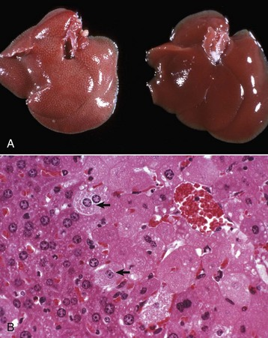
FIG. 1-11 Acute cell swelling, liver, mouse.A, Hepatic swelling in a mouse exposed to chloroform 24 hours previously. The accentuated lobular pattern and slight pallor in the liver on the left are the result of acute cell swelling (hydropic degeneration) and necrosis of centrilobular hepatocytes. The right liver is normal. B, Liver from a mouse with chloroform toxicosis. While many hepatocytes in the centrilobular areas (at right) are necrotic, several cells at the interface of normal and necrotic (arrows) are still undergoing acute cell swelling (hydropic degeneration). H&E stain. (Courtesy Dr. L.H. Arp.)
Microscopic Appearance: The influx of water dilutes the cytoplasmic matrix and dilates organelles to give cells a pale, finely vacuolated appearance (cloudy swelling). Renal tubule epithelial cells bulge and impinge on the tubular lumen. Swollen hepatocytes and endothelial cells intrude upon and diminish vascular lumens. Although mechanisms of cell swelling are limited, variations in appearance may occur because of differences in cell type and cause of injury.
Hydropic degeneration is a common term used for the microscopic appearance of acute cell swelling (Fig. 1-11, B). It occurs in endothelium, epithelium, alveolar pneumocytes, hepatocytes, renal tubular epithelial cells, and neurons and glial cells of the brain. Cytoplasm of affected cells contains translucent vacuoles that fail to stain for fat or glycogen (two other causes of vacuolar degeneration). These vacuoles represent swollen mitochondria and dilated cisternae of the Golgi and ER. Ballooning degeneration is an extreme variant of hydropic degeneration in which cells are greatly enlarged and the cytoplasm is basically a clear space (Fig. 1-12). Ballooning degeneration is typically seen in epidermal cells infected by epitheliotropic viruses (e.g., poxvirus). This lesion frequently progresses to the formation of vesicles or bullae (blisters) from lysis of the epidermal cells. These viral infections cause both degradation of cytoplasmic proteins (cytoplasmic proteolysis) and net flux of water into the cytoplasm.
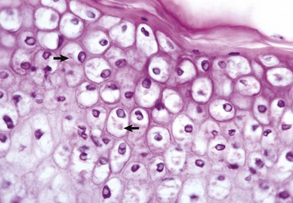
FIG. 1-12 Ballooning degeneration, papular stomatitis, oral mucosa, cow.Cells infected by some types of virus, such as papular stomatitis virus, are unable to regulate their volume and swell at certain stages of the infection. These cells may become very large (ballooning degeneration) and eventually rupture. Some of the cells have viral inclusion bodies (arrows). H&E stain. (Courtesy Dr. M.D. McGavin, College of Veterinary Medicine, University of Tennessee.)
Ultrastructural Appearance: As visualized with the electron microscope, swollen epithelial cells have lost and distorted cilia, microvilli, and attachment sites, as well as “blebbing” of cytoplasm at the cell surfaces. The cytoplasm is rarefied, and the cisternae of the ER, Golgi, and mitochondria are dilated. The cytocavitary network becomes fragmented into numerous vesicles. Proteins and Ca²⁺ precipitate in the cytoplasm and in organelles. Acute cell swelling in the central nervous system has other distinctive features (see section on Cerebral Edema in Chapter 14).

Significance and Fate of Acute Cell Swelling
Injured cells that can no longer regulate water and electrolytes are no better equipped to maintain other cell functions. Significance to the patient depends on the number of cells affected and the immediate importance of the lost cell function. Cells highly vulnerable to hypoxia and cell swelling include cardiac myocytes, proximal renal tubule epithelium, hepatocytes, and endothelium. In the central nervous system (CNS), besides endothelium, neurons, oligodendrocytes, and astrocytes also are swollen, and the process in the CNS is called cytotoxic edema (see Chapter 14). Swollen neurons fail to conduct nervous impulses, resulting in stupor or coma. Swollen myocardial cells contract with less force or with an abnormal rhythm. Swollen renal epithelium may not only fail to absorb and secrete but also may compress delicate interstitial blood vessels, resulting in further injury. Capillaries lined by swollen endothelium are prone to obstruction, exacerbating the lesions by worsening cellular hypoxia. Injured cells with abnormal membrane permeability may be detected by finding their specific cytoplasmic enzymes in serum.
If adequate oxygen is restored to the cells and membrane injury is repaired before a certain point is reached, the “point of no return,” most cells can be restored to normal or nearly normal function. Some cells may retain evidence of previous injury in the form of lipofuscin accumulation after autophagocytosis of damaged organelles. What happens when the stage of reversibility is passed is the topic of the next sections, beginning with cell death.
In summary, cell swelling is a manifestation of reversible, sublethal cell injury. However, unless the cause of injury to critically important cell types is removed quickly, progressive injury to these dependent cells and tissues may culminate in the death of the animal.

Irreversible Cell Injury and Cell Death
As we have just seen, major mechanisms of acute cell swelling are hypoxia, including ischemia, and membrane injury, often by toxins. Cell swelling can be reversible if the extent and duration of injury is not excessive. But if the injury exceeds certain limits (discussed shortly), cell death occurs (Fig. 1-13). Not all cell injury results in cell death. Cell injury may be sublethal and result in a variety of types of cell degenerations and/or adaptations by the cell to the injury. In essence, cells or tissues respond to injury (or stress) in three important ways: (l) adaptation (with or without accumulations or degenerative changes), (2) reversible injury (again with or without subcellular changes), and (3) death. In this section, we deal with cell death. Various types of cell adaptations, degenerations, and accumulations are addressed in subsequent sections.
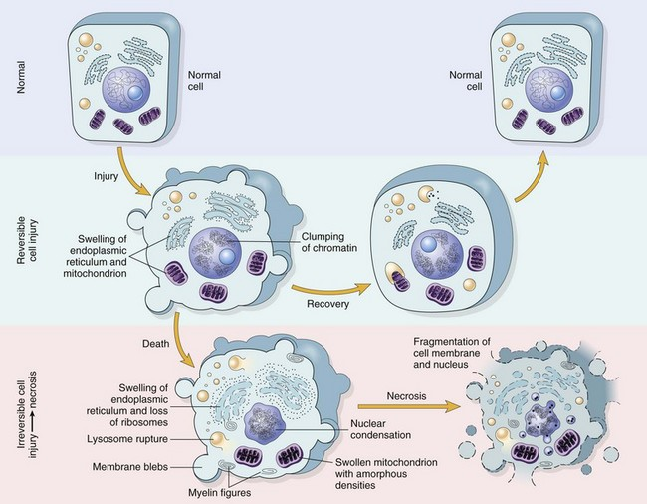
FIG. 1-13 Normal cell and the changes in reversible and irreversible cell injury.Reversible injury is characterized by generalized swelling of the cell and its organelles, blebbing of the plasma membrane, detachment of ribosomes from the endoplasmic reticulum, and clumping of nuclear chromatin. Transition to irreversible injury is characterized by increasing swelling of the cell, swelling and disruption of lysosomes, presence of large amorphous densities in swollen mitochondria, disruption of cellular membranes, and profound nuclear changes. The latter include nuclear condensation (pyknosis), followed by fragmentation (karyorrhexis) and dissolution of the nucleus (karyolysis). Laminated structures (myelin figures) derived from damaged membranes of organelles and the plasma membrane first appear during the reversible stage and become more pronounced in irreversibly damaged cells. (From Kumar V, Abbas A, Fausto N: Robbins & Cotran pathologic basis of disease, ed 7, Philadelphia, 2005, Saunders.)

Cell Death
Cell death can occur in many ways. For example, extremes of temperature or direct trauma may result in nearly instantaneous destruction or death of cells. On the other hand, death of an animal (somatic death) results in eventual death of all cells that make up the animal (postmortem autolysis). During most of the last century, cell death and necrosis were thought of as being more or less the same and in most pathologic situations; necrosis was usually thought to be preceded by cell swelling as discussed earlier. It is clear that cells die before macroscopic or histologic evidence can be detected. Although necrosis can be defined as the death of cells in a living animal, it should be understood to mean the specific morphologic changes (either macroscopic or microscopic) indicative of cell death in a living animal.
In the last few decades of the twentieth century, it became clear that cells die also by shrinkage, both under physiologic and pathologic circumstances, and this complex and now well-studied process has become known as apoptosis, a type of programmed cell death. Cell death then began to be classified in two major types: necrosis or apoptosis. Because of the long history of use of necrosis and because apoptosis, cell death with shrinkage, is distinctly different from death following swelling, the term oncosis (onco-, meaning swelling) has been proposed for what was previously termed necrosis. As in most biologic processes, it is not always possible to make the distinction between these two types of cell death based on histologic examination, and often both swelling and shrinkage are present.
How then are we to use the term necrosis? Attempts are being made by toxicologic pathologists to use the term necrosis for the histologic changes that occur after cell death by either mechanism, using the terms oncotic cell death or apoptotic cell death when a distinction needs to be made. We attempt to adhere to this distinction here, but long-used terminology does not easily change. The next sections first discuss cell death after irreversible cell injury by hypoxia and cell membrane damage (oncotic necrosis), and then apoptosis or apoptotic necrosis (Fig. 1-14).
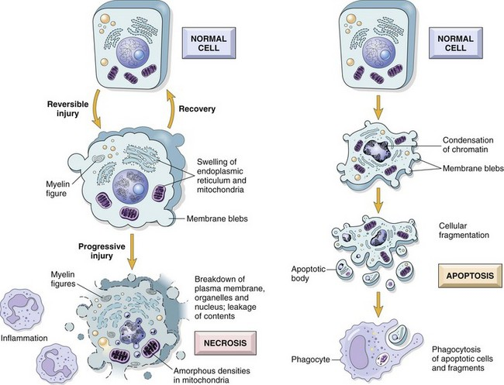
FIG. 1-14 The sequential ultrastructural changes seen in necrosis (left) and apoptosis (right).In apoptosis, the initial changes consist of nuclear chromatin condensation and fragmentation, followed by cytoplasmic budding and phagocytosis of the extruded apoptotic bodies. Signs of cytoplasmic blebs, accumulation of myelin figures representing damaged phospholipid membranes, and digestion and leakage of cellular components characterize necrosis. (From Kumar V, Abbas A, Fausto N, et al: Robbins & Cotran pathologic basis of disease, ed 8, Philadelphia, 2009, Saunders.)

Cell Death by Oncosis (Oncotic Necrosis)
Oncosis is cell death after irreversible cell injury by hypoxia, ischemia, and direct cell membrane injury. Hypoxic injury, as discussed earlier in the section on Acute Cell Swelling, is a common cause of cell death and oncotic necrosis. Cell membrane damage caused by toxins and other substances and mechanisms can also lead to necrosis, but the resulting morphologic changes are similar. Hypoxia is often due to blockage of or markedly diminished blood supply to an area (ischemia). Ischemic injury is typically more severe than hypoxia alone because not only is the amount of oxygen lowered in the tissue, but also the inflow of metabolic substrates and nutrients is decreased and cell waste and by-products accumulate, some of which are injurious in their own right.
Acute cell swelling can result in necrosis or can be reversible. Despite much interest and research about where the exact point of no return is between injury that is reversible and where it is irreversible, resulting in necrosis, is still not clear. There is convincing evidence for the role of Ca²⁺ in the eventual demise of severely injured cells. Earlier work consistently identified two features of irreversible cell injury: (1) an inability to restore mitochondrial function and (2) evidence of cellular membrane damage.
Research directed at understanding coronary heart disease has led to improved understanding of the role of Ca²⁺. Heart muscle deprived of its blood supply (ischemia) suffers from hypoxia and substantial loss of cell volume regulation and the influx of Ca²⁺ because of inadequate ATP to run the ion pumps. If the blood supply is resupplied to the ischemic area, often reversal of the injury is not attained, but instead, injury is accelerated. It has been shown that restored blood flow to areas with potentially viable cells results in added membrane damage shortly after blood supply is reestablished. This phenomenon is termed ischemia-reperfusion injury.
Prevention of Ca²⁺ influx can reduce irreversible injury. The reactivity of free Ca²⁺ ion and its role as an intracellular messenger and enzyme activator are known, and these actions are thought to contribute much to the final demise of the cell in necrosis. What does Ca²⁺ do to cause the ultimate demise of many severely injured cells as it influxes from the extracellular space (Fig. 1-15)? At least one endogenous, membrane-bound phospholipase (phospholipase A) is activated by free Ca²⁺. Activated phospholipases then break down the normal phospholipids of the inner mitochondrial membrane and other cell membranes. These events then preclude any possibility for cell survival. Activation of phospholipases also generates arachidonic acid, the substrate for many lipid mediators of inflammation (to be discussed later). Therefore it is usual to see some degree of inflammation around foci of necrosis. In addition to phospholipases, Ca²⁺ also activates proteases that result in cytoskeleton and membrane damage, adenosine triphosphatases (ATPases) that accelerate depletion of ATP, and endonucleases that result in chromatin degradation. Irreversible injury to mitochondrial membranes appears to be the deathblow to the cell. As if this were not enough, cells injured by ischemia can also die by apoptosis because of the leakage of proapoptotic molecules from injured mitochondria.
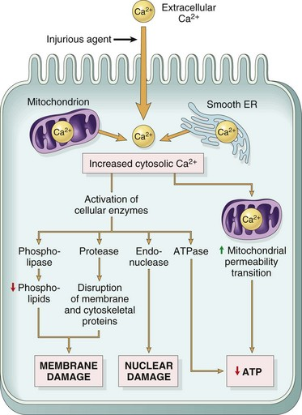
FIG. 1-15 Sources and consequences of increased cytosolic calcium in cell injury.ER, Endoplasmic reticulum; ATP, Adenosine triphosphate. (From Kumar V, Abbas A, Fausto N, et al: Robbins & Cotran pathologic basis of disease, ed 8, Philadelphia, 2009, Saunders.)

